Investigating Probability

Introduction

You will need your results for the dice experiment generated on a graphical calculator
- Set up a spreadsheet for the results as shown below. You will need six columns in total (or more if more than two people worked together).

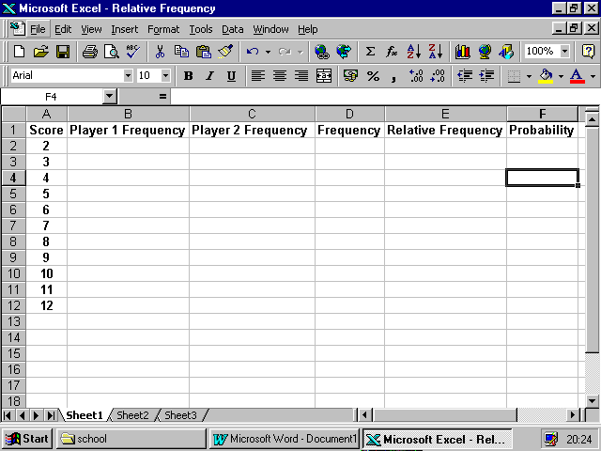

Task One
- Use the results from your experiment last lesson to fill in the scores in columns 1 and 2.

- Use the formula function of the spreadsheet to calculate the frequencies of your scores. Put these results into the fourth column.

- In cells B13, C13 and D13 work out the total frequencies using a formula. If you have done this correctly they should be 60, 60 and 120, but you must check!

- Now in column 5 use a formula to calculate the relative frequency for each total. Use Edit, Fill, Down to replicate the formula – it is much quicker. The computer will automatically write these as decimals. [Remember: relative frequency is the number of ‘favourable’ outcomes divided by the total number of outcomes]

Task Two

Now you are going to compare these results with the theoretical probability

- First you need to calculate these probabilities by using a table (or possibility space). Set it up on another sheet as shown over the page.

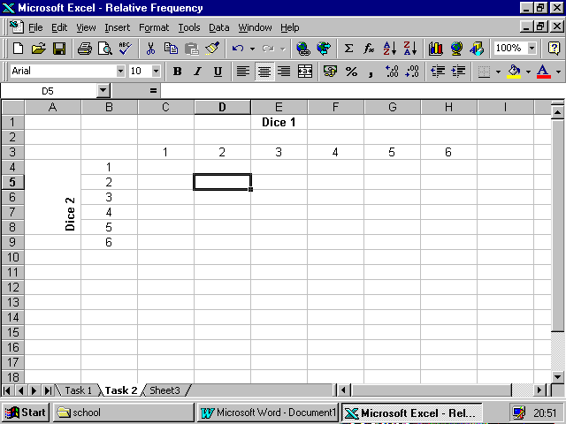
- Use formulas to fill in the totals in each of the appropriate spaces.
- Colour in each different number a different colour. If you have calculated correctly there should be an obvious pattern in the colours.
- Now use your table to read off the probabilities and fill in column 6 of the first spreadsheet.
- Format the cells as ‘Number’ and set to 3 decimal places.
- Check that all the probabilities add up to 1 using the formula function.

Task Three

Now you are going to compare the experiment with the theory
- Use the graph drawing function to construct a comparative bar chart for the relative frequency against the probability.
- Label the axes and give your chart a title. It should look something like the one below.
- 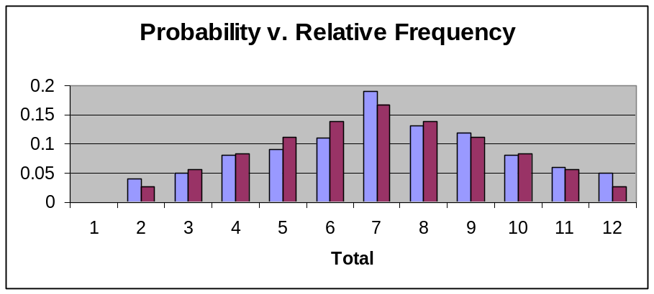Write a short report about what you have found out in these tasks and include reasons why you think these things are happening.

